Enhanced Crystal Set Performance
Using a Beat Frequency Oscillator
for Exalted Carrier Reception

Mike Tuggle

Introduction. Being a crystal set ‘purist’ means, to me, no power or amplifiers. I had back off that stance with the Hawaii long wave (LW) scene. Only three local LW beacons could be heard -- one of those only at night. It’s well known that a beat frequency oscillator’s (BFO) signal, when applied to an inaudible continuous wave (CW, code) signal, will make it audible. It’s perhaps less well known that the same BFO applied to amplitude modulated (AM) signals, as used in the broadcast band (BCB), can greatly increase their strength and readability. This effect is ‘exalted carrier’ reception.

The BFO is nothing more than a signal generator. As we shall see, it can be a lot less. By loosely coupling the output of a small signal generator and tuning it to the frequency of the LW crystal set, many more LW beacons were heard.

Exalted Carrier Reception. Crystal sets by their nature are inefficient in detecting weak, distant (DX) signals. Tuning a BFO to the carrier of a weak DX signal raises the voltage of the signal to a region of much more efficient detection. Exalted carrier is amplification of sorts, but it is different from regeneration or reflexing – here, the set is continuously in oscillation. In the case of an isolated weak DX signal, exalted carrier raises the signal to the level of readability. When the weak DX signal is 'buried' by a strong interfering (QRM) signal, exalted carrier selectively raises the level of the DX signal. The hope is, the DX signal can be raised to a level at which the brain can select the DX program in the presence of the QRM program. There must be more high-powered explanations around, but that's the gist of it.

In a way, exalted carrier is related to direct current (DC) biasing of the detector diode to get to a more efficient detection region. But exalted carrier is radio-frequency (RF) ‘biasing’ of the detector at a specific frequency – very important distinction.

Exalted carrier reception is not new. Early on, hams discovered that weak AM signals could be enhanced by tuning them in using the single sideband (SSB) mode. Here again a local oscillator in the receiver is tuned to zero beat with the AM carrier. These rigs had the further advantage that you could select the sideband (lower, upper) you want to listen to. Many of the older top-of-the-line communications receivers, Hammarlund, National, etc., include it among their features.

Beat Frequency Oscillator (BFO). My original BFO, a small EICO 330 solid state signal generator, served well to bring in a variety of distant LW beacons. In late-2004/early-2005, a new One-Active Device (1-AD) contest to complement the Crystal Set DX contest was announced. Steve McDonald suggested that I should try applying the BFO idea to BCB reception in the 1-AD contest.

Because of the 1-AD Contest limit of one active device – 1 tube or 1 transistor -- I planned to replace the EICO with a simple, one-JFET Hartley BFO as "proof-of-concept" and then to build from there. As it turned out, there was little need to go beyond this basic one-JFET set.

The schematic and circuit board pictorial of this textbook BFO are shown below.
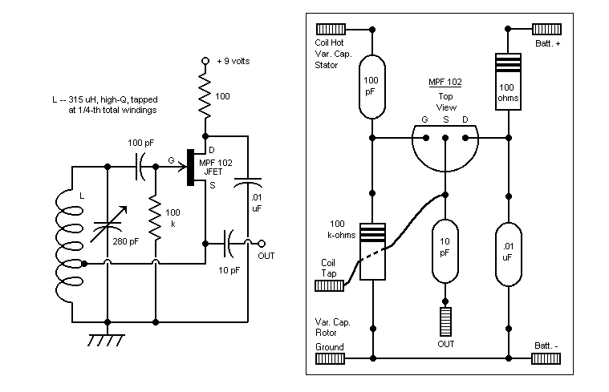

The BFO is connected to the crystal set by attaching a clip lead to the OUT post and loosely wrapping the lead around the crystal set’s antenna lead-in wire. The BFO and crystal set grounds are not connected. The coil and tuning capacitor should be high Q to keep the oscillations sharp as possible.

The BFO is very frequency-stable in the short term in spite of there being no supply voltage regulation provisions. I planned to address voltage regulation in Phase II, but never got that far. 'Warm-up time' is 10 to 15 seconds. I can tune in a station, turn off the BFO for an hour or so, then turn the set back on to hear a high-pitched whistle descend exactly to zero beat in a matter of seconds. One thing working for frequency stability is the low current draw, only about 0.3 mA.

Now, let’s look at this BFO applied to long wave and BCB crystal sets.

Long Wave (LW) BFO Receiver.

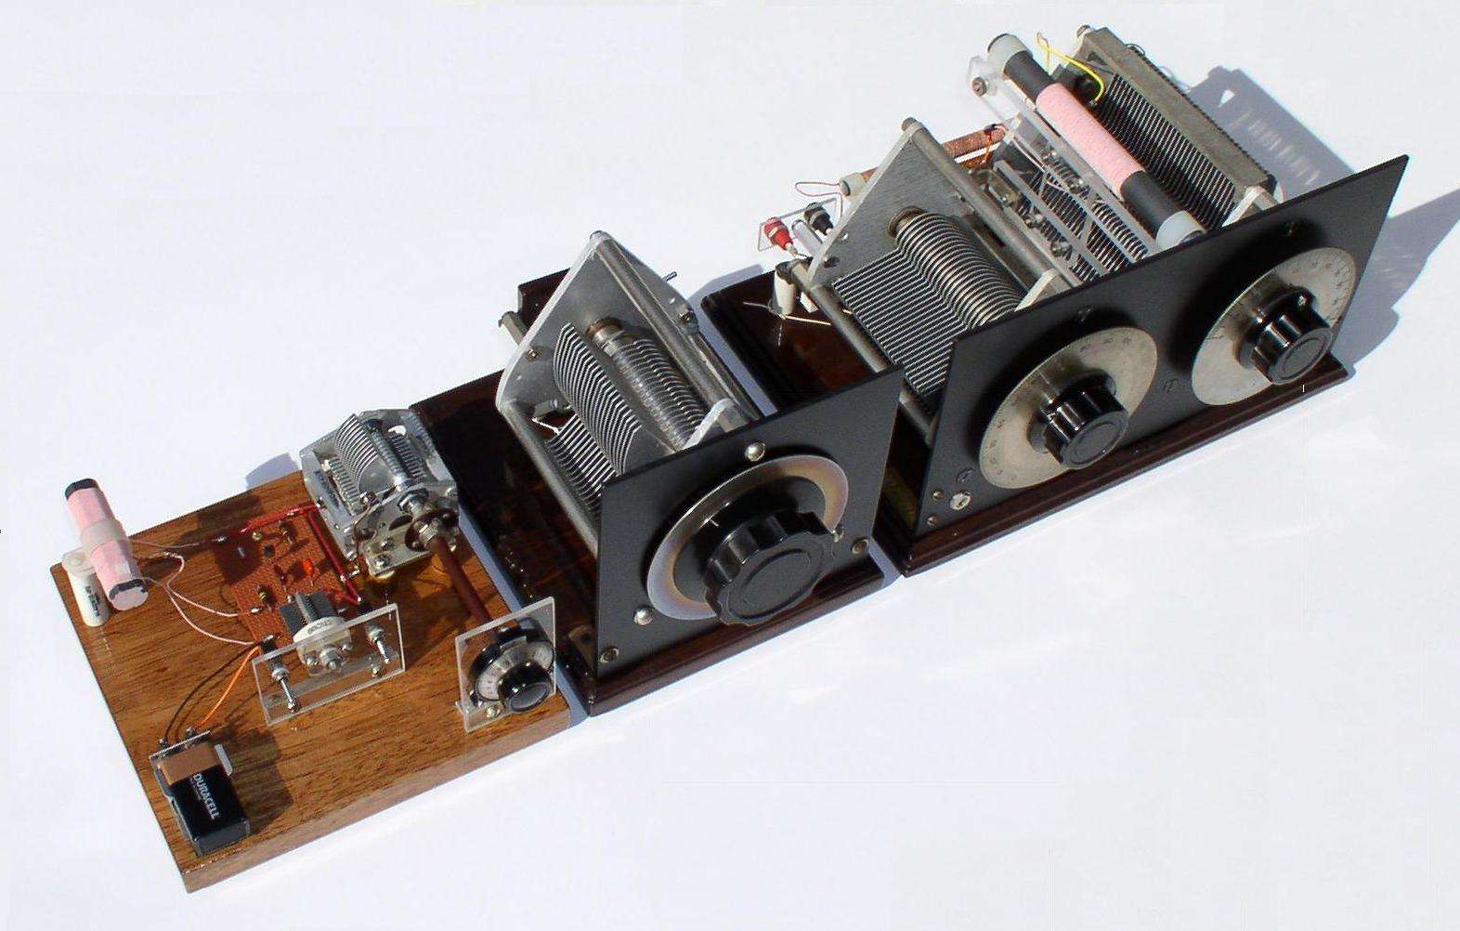

At left is the 1-MPF 102 JFET BFO. In center is a 1000 pF variable capacitor shunted across the BFO's tuning capacitor to get to low frequencies. (The BFO was originally designed to cover the BCB.) The two-dial unit to the right is a double-tuned LF crystal set. Also used but not shown are sound powered phones and matching transformer. A clip lead from the BFO output is wrapped around the crystal set's antenna lead-in for injection. The BFO provides exalted carrier for AM signal reception or an audible beat note for CW reception. The complete circuit is shown below:

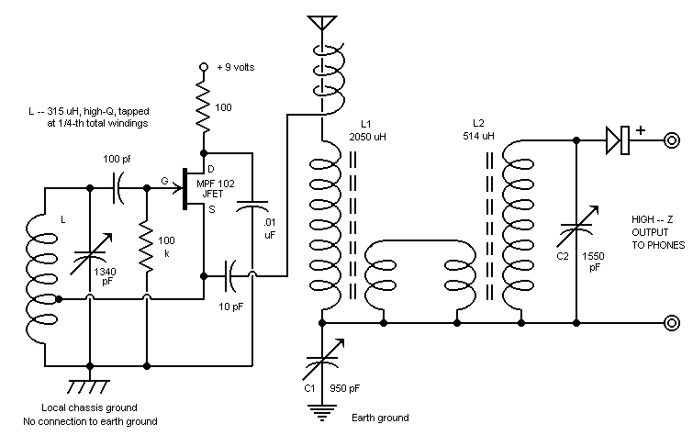

The crystal set itself is a series-tuned front-end loosely coupled to a parallel-tuned secondary detector section. Of several designs I tried, this one seemed to work best. This set has received over 80 LW beacons covering the Pacific area, from Samoa to the Aleutians, west to Japan and well into the mid-western states. The most distant is beacon DDP in San Juan, Puerto Rico at 5850 miles. DDP is notable for its wide coverage.

In mid-winter months when propagation is best, ‘local’ beacon LLD, 70 miles away on the island of Lana`i, provides a very powerful signal and carrier. In fact, so powerful LLD’s carrier itself can exalt the signals of beacons nearby in frequency. Stations heard with the local BFO turned off include ones in British Columbia, Alaska, Montana and the Cook Islands. All it takes is some careful listening in the silent spaces between the loud LLD idents. In essence this is crystal set operation with a remote BFO – 70 miles remote! This effect is much more prevalent on the mainland where there is likely to be a much higher density of strong local beacons. At my former Maryland location, I never thought to use an amplifier or a BFO.

Medium Wave (MW)/BCB BFO Receiver.

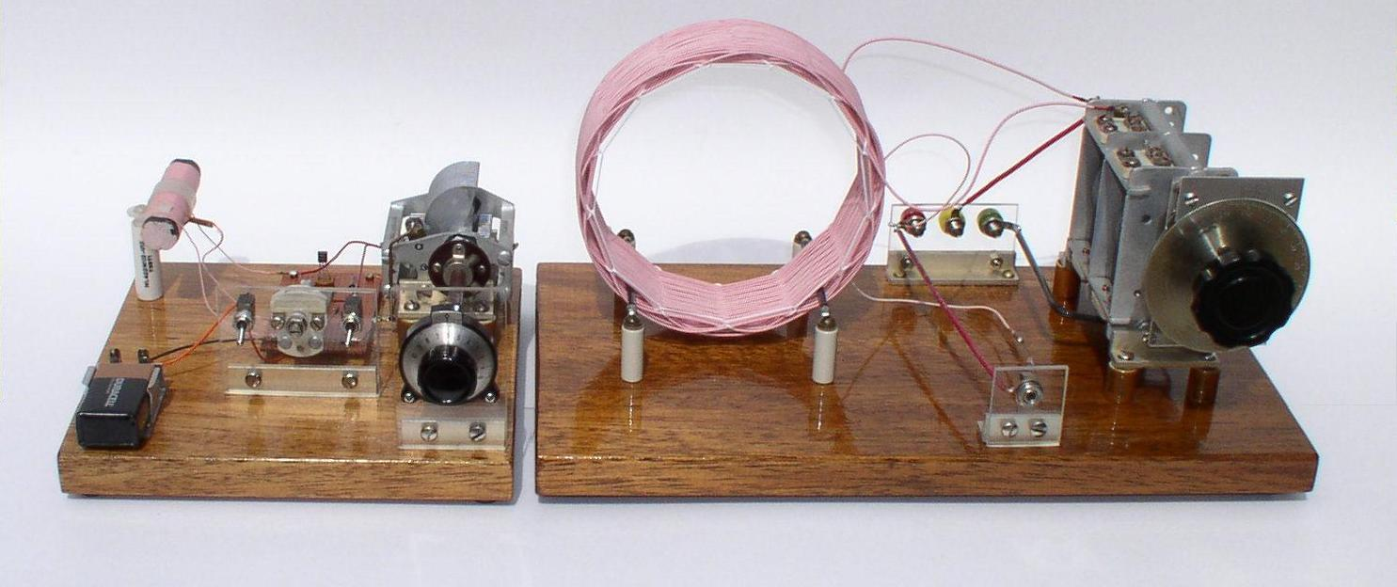

The one-MPF 102 JFET BFO is loosely coupled to a modified MRL 39 single-tuned crystal set. The BFO is at left. Again, matching transformer and sound powered phones are not shown. The BFO is coupled to the MRL 39 by wrapping a few turns of a clip lead from its output around the antenna lead-in. The circuit is shown below.

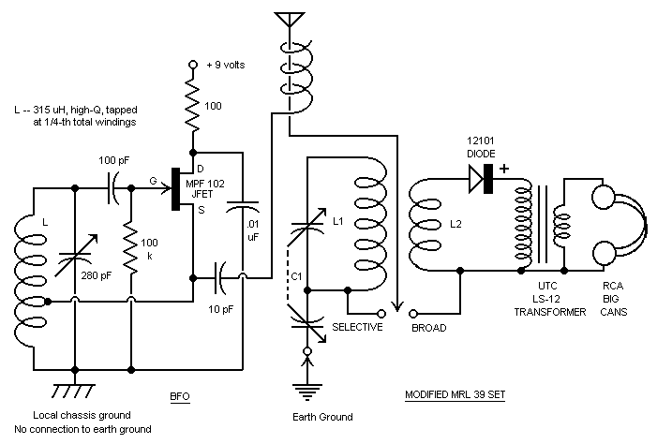

Performance. An indicator of the sensitivity of this set is the ring in the phones when either BFO or MRL 39 tuning capacitor is lightly rapped, causing the plates to vibrate. This is classic frequency modulation about the zero beat. Equally significant is greatly enhanced selectivity -- so much so a wave trap is rarely needed. There is splatter on the baddest actors, but that's the station, not the set.

The strongest (non-splattering) local stations were noted to 'pervade' the spectrum several tens of kilohertz to either side of their center frequencies. This is because the MRL 39 set, good as it is, has only so much selectivity. You can tell when an off-channel local is present because its audio quality is not affected by re-adjusting the BFO. As described below, on-channel audio quality is greatly affected by tweaking the BFO exactly to its frequency.

No set is perfect. Here are some drawbacks:

The simple BFO does have harmonic content. The BFO is going to exalt strong signals at 2x, 3x, 4x, etc. the frequency you're tuned to. For me, this means local stations at 1080, 1500 and 1540 show up at 540, 750 and 770 kHz and make listening to these frequencies difficult. 2.5 MHz WWVH ties up 1250 kHz -- I also hear them on 625 kHz. A far greater threat – especially for the MRL 39 set -- is all the short wave (SW) going on, especially in the evening. Fortunately, my location is in the SW boonies.

A spotter radio is near-useless -- dead as a doornail. Front-end overload by the BFO signal causes automatic gain control (AGC) clamping in the spotter. Turning the BFO off brings the spotter back to life. But you can't listen to both simultaneously to verify identical program content. It's not that difficult without the spotter. Tune to a known station and 'count channels' to either side by noting the ascending/descending pitch squeal to the next zero beat. The ideal spotter would be a digital readout radio whose AGC can be disarmed.

The BFO requires some deft tuning to get exact zero beat. At the top end, this is nearly impossible -- so I tune as close as I can and then zero-beat by judiciously positioning my left hand near the BFO -- a hand capacitance vernier. Because BFO tuning is so touchy, I chose the MRL 39 single-dial crystal set over the two-dial Lyonodyne-17. Even when the carrier is zero-beat the audio is degraded because the modulation sidebands are off-frequency. Speech sounds like SSB 'duck talk,' and music can get trashed beyond recognition. But we're talking DX here, not hi-fi, easy music listening from the Lazy Boy.

I discovered that frequency stability does suffer over the very long term as the battery supply decays. On the last night of the 1-AD Contest, I switched out of desperation to a new battery. (The old one had been in continuous evening use for almost four months.) With the new battery, BFO calibration points were shifted by a small but noticeable half-percent or so.

Future Improvements.

Top of the line Fair Radio 500 pF capacitor. May need to reduce the inductance of the coil a little to spread the band out.

Improved vernier dial -- something larger, perhaps even a double vernier drive.

Variable level injection -- through an actual var. cap. instead of the gimmick.

Harmonic suppression -- low-pass filter, or tuned parallel tank as a notch filter. At the same time I don't want to shoot myself in the foot by attenuating high-end BCB BFO output.

Conclusion.

To folks considering trying this idea, I’d suggest, Don’t build anything at first – try out a signal generator ‘BFO’ on one of your own crystal sets. Remember to keep the generator output low and the coupling to the set as loose as possible. It doesn’t take much at all. If performance seems promising after several evenings of listening, e.g., SW is not a problem, then consider a ‘dedicated’ BFO such as described above.

I’m convinced that part of the impressive performance of these BFO’ed crystal sets is due simply to the crystal set itself. A well designed and constructed crystal set has outstanding qualities – among them, sensitivity, selectivity, low noise – desirable in the front-end of any radio set. We all know from experience that crystal sets, by themselves, can ‘hold their own’ with the big rigs.

I think the advantage of exalted carrier over other forms of amplification (regeneration, reflexing, etc.) is that the amplification is applied to a selected frequency. While a tuned RF amplifier may come close, it’s hard to imagine a more effective use of a single active device to improve crystal set performance than by exalting the carrier with a simple BFO.

