248

The Boy Electrician

The Receiving Apparatus

The Receiving instruments from the most interesting part of a wireless station and usually receive first attention from the amateurs. They are the ears of the wireless station and are wondrously sensitive , yet are very simple and easy of construction.
The instruments necessary for receiving are:
A Detector,
A Tuning Coil or a Loose Coupler ,
A Fixed Condenser,
A Telephone Receiver .
Other devices, such as a test buzzer, variable condenser, etc., may be added and will improve the outfit.
After the aerial has been properly erected, the first instrument necessary to construct will be either a tuning coil or a loose coupler. It is a good plan to make a tuning coil first, and a loose coupler after you have had a little experience with your apparatus.
A tuning Coil is a very simple arrangement which makes it possible to receive messages from greater distances, and also somewhat to eliminate any messages not desirable and to listen without confusion to the one wanted.
A tuning coil consists of a single layer of wire wound
upon a cylinder and arranged so that connection may
be had with any part of it by means of a sliding con-
tacts.
The cylinder upon which the wire is wound is a card- board tube six and three-quarters inched long and two and
249

seven-eighths inches in diameter outside. It should be given two or three coats of shellac both inside and out so that it is thoroughly impregnated, and then laid away until dry. This treatment will prevent the wire from be- coming loose after the tube is wound, due to shrinkage of the cardboard.
After having become dry, the tube is wound with a single layer of No. .25 B. & S. gauge green silk-covered wire. The

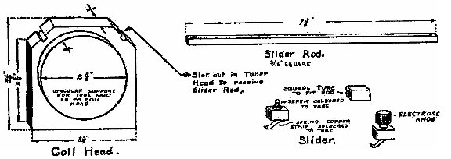



FIG. 201. -Details of the Tuning Coil

wire must be wound on very smoothly and tightly, stop- ping and starting one-quarter of an inch back from each end. The ends of the wire are fastened by weaving back and forth through two small holes punched in the card - board tube with a pin.
The winding should be given a single coat of clear var- nish or white shellac and allowed to dry .
The coil heads or end pieces are cut from one-half-inch wood according to the plan and dimensions shown in the accompanying illustration.

250
THE BOY ELECTRICIAN
The top corners are beveled and notched to receive the slider-rods. A circular piece of wood two and five-eighths inches in diameter and three-eighths of an inch thick is nailed to the inside of each of the coil heads to support the ends of the cylinder.
The wooden parts should be stained mahogany or some other dark color and finished with a coat of shellac or varnish.
The slider-rods are square brass 3-16 x 3-16 inches and seven and three-quarters inches long. A small hole is bored near the ends of each, one-quarter of an inch from the edge, to receive a round-headed brass wood screw which holds the rod to the tuner end.
The sliders may be made according to the plan shown
in Figure 20 I.
The slider is made from a small piece of brass tubing, three-sixteenths of an inch square. An 8-32 flat-headed brass screw is soldered to one face, in the center. A small strip of phosphor bronze sheet or spring copper soldered to the bottom of the slider forms a contact for making con- nection to the wire on the cylinder. A small " electrose "
knob screwed to the slider makes a neat and efficient handle.
Two sliders are required, one for each rod.
The tuning coil is assembled as shown in Figure 203. The cardboard tube is held in place by several small brass nails driven through it into the circular pieces on the coil heads.

251
WIRELESS TELEGRAPHY

A slider is placed on each of the slider-rods and the rods fastened in the slots in the coil ends by a small round- headed brass screw, passing through the holes bored near the ends for that purpose.
Two binding-posts are mounted on one of the coil ends.

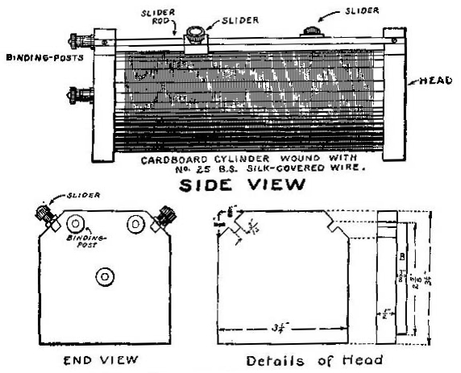

Fig. 202.—Side and End Views of the Tuning Coil.
One should be connected to each of the slider-rods. A third binding-post is placed below in the center of the head and connected to one end of the wire wound around the cylinder.

A small, narrow path along the coil, directly underneath each slider and to which the copper strip can make contact,
252

THE BOY ELECTRICIAN

must be formed by scraping the insulation off the wire with a sharp knife. The sliders should make contact with each one of the wires as they pass over, and should slide smoothly without damaging or disarranging any of the wires.
When scraping the insulation, be very careful not to loosen the wires or remove the isulation from between

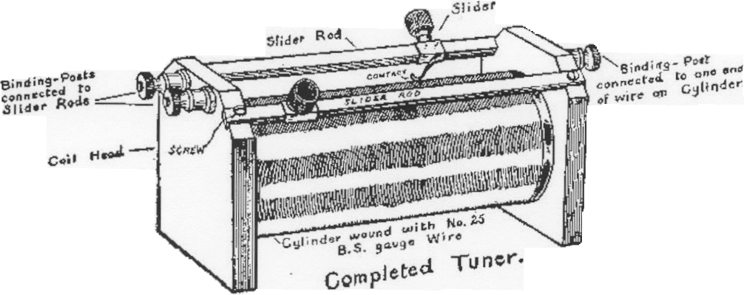
FIG. 203. -Complete Double-Slider Tuning Coil.

them, so that they are liable to short circuit between ad-
jacent turns.
A Loose Coupler is a much more efficient tuning device than a double-slider tuner, and sooner or later most amateur wireless operators install one in their station.
The loose coupler shown in the figure given on the next page is a very simple one and is both easy and inexpensive to build. Its simplicity is a disadvantage in one respect, however. Owing to its construction, it is impossible to move the slider on the secondary when the latter is inside the primary. The reason that I have chosen this sort of

253

WIRELESS TELEGRAPHY
loose coupler to describe is to acquaint my young readers with the methods of making a loose coupler .
The "Junior" loose coupler described farther on is a more elaborate instrument of greater efficiency, but much harder to build.
The base of the loose coupler is of wood and measures twelve by four inches. The head supporting the primary is of the same size as those used on the " Junior " double- slide tuning coil just described. It may be made in the

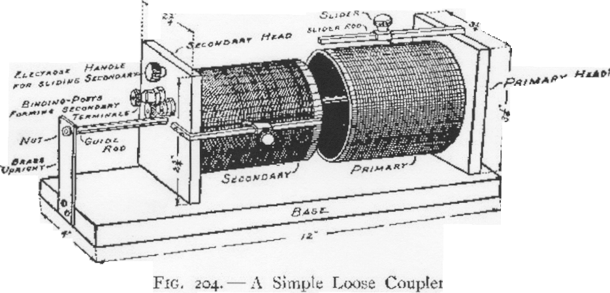
same manner, and fitted with a circular block to support the tube. The primary tube is of the same diameter as that on the tuning coil but is only four inches long. It is fastened to the primary head with glue and then secured with a number of small tacks. One or two coats of shellac liberally applied will render it non-shrinkable, so that the wire will not be apt to loosen after the loose coupler has been in use a while.
The secondary is of the same length as the primary, but

254 THE BOY ELECTRICIAN

of smaller diameter, so that it will easily slip inside. It also is treated with shellac.
The primary should be wound with a single layer of No. 22 single-siIk -covered magnet wire. The secondary is wound with No. 29 single-silk.
The head supporting the secondary is smaller than that used for the same purpose on the primary. The round boss to which the tube is fastened, however, is much thicker.
The secondary slides on a" guide-rod " supported at one end by passing through the primary head and at the other by a brass upright. The upright may also be made of wood.
If the secondary is " offset," that is, placed out of center slightly to one side, it win leave room so that the secondary slider will possibly pass inside of the primary without striking.
Both the primary and the secondary must be fitted with " sliders " to make contact with the various turns of wire.
The method of constructing a slider has already been described.
The ends of the slider-rods are bent at right angles and fastened to the coil heads b)1' two small screws passing through holes bored near the ends. A small narrow path must be scraped in the insulation under each so that the slider will make con tact with each turn. The secondary head may be provided with a small electrose handle to facilitate sliding it back and forth.
Two binding-posts are mounted on each of the coil heads.
.

WIRELESS TELEGRAPHY 255
One post on each is connected to the end of the coil farthest from the head, and the other posts are each connected to the slider-rods.
Figure 220 shows how to connect the loose coupler in the receiving set.
In order to tune with a loose coupler, first adjust the slider on the primary until the signals are the clearest. Then set the secondary slider in the best place and move the secondary in and out of the primary untill the signals are clearest.

How to Build the Junior Loose Coupler
A loose coupler of the sort just described is simple and quite easily constructed, but will not be found to work as well as one in which the secondary may be varied by means of a switch while it is inside of the primary.
The base of the instrument measures twelve by three and five-eighths inches. The primary is composed of a single layer of NO.24 B. & S. gauge single-silk-covered wire wound on a cardboard tube two and three-quarter inches in diameter and three and three-quarter inches long. The winding is laid on in a single layer and should comprise about 150 turns. After winding on tightly, it should be given a coat of clean white shellac and allowed to dry. The shellac is for the purpose of fastening the wire down tightly to the tube So that it will not loosen when the slider is moved back and forth.
The primary is mounted between two heads, the details

256 THE BOY ELECTRICIAN
of which are shown in Figure 205. One of the heads, B, has a flanged hole two and three-quarter inches in diameter cut through the center so as to receive the end of the tube and permit the secondary to pass inside.
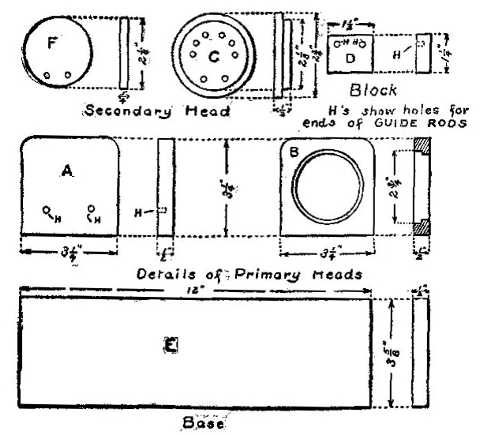

FIG. 205 ,- Details of the Wooden Parts.
The secondary winding is composed of. a single layer of NO.28 B. & S. gauge silk-covered wire and divided into six equal sections. The secondary is supported by two circular wooden pieces, C and F, and slides back and forth on two guide-.rods. The guide-rods should be brass. Iron or

WIRELESS TELEGRAPHY 257

steel rods running through the center of a loose coupler will seriously weaken the signals, and such practice must by all means be avoided.

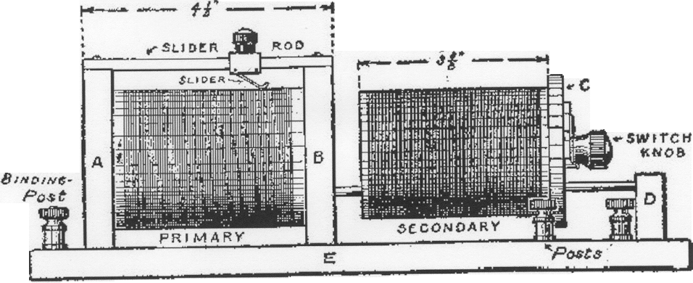
Side View

FIG. 206. -Side View of the Loose Coupler.

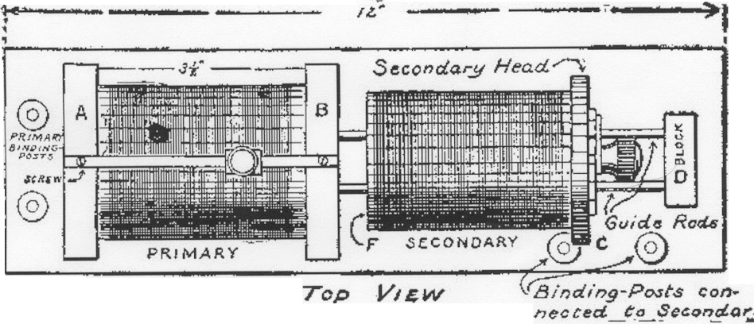
FIG. 207. -Top View of the Loose Coup1er.

The Secondary sections are connected to six contacts and a switch-arm mounted on the end of the secondary so that by turning the switch either one, two, three,fout, five, or six sections of the winding may be connected.

258 THE BOY ELECTRICIAN
The two binding-posts near the secondary end of the coupler are connected to the terminals of the secondary winding by means of two flexible wires. They have not
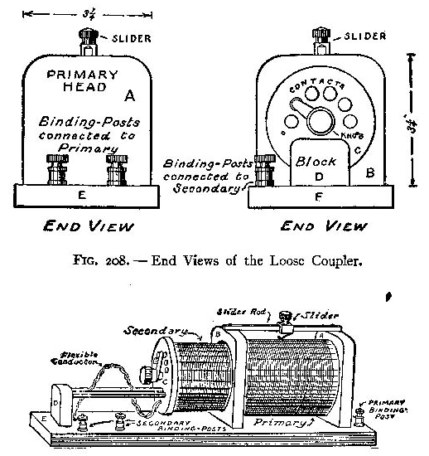

FIG. 209. -CompJetc Loose Coupler.

Fig. 209.—Complete Loose Coupler.
been shown in several of the illustrations because they would be liable to confuse the drawing.
The primary is provided with a slider moving back and forth over a narrow path scraped through the insulation so that it may make contact with each wire independently.

WIRELESS TELEGRAPHY 259

Detectors

Detectors are very simple devices and consist merely of an arrangement for holding a small piece of certain minerals and making a contact against the surface.
The crystal detector shown in Figure 210 is a very efficient form that may be easily and quickly made. When finished, it will make a valuable addition to almost any
amateur experimenter's
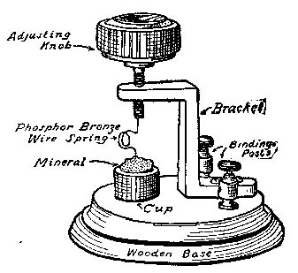
wireless equipment.
The bracket is bent
out of a piece of strip
brass a bout one-eighth
of an inch thick and
five-eighths of an inch
wide according to the
shape shown in the illus-
tration. The bracket is
mounted on a circular
wooden base about three inches in diameter. The circular wooden blocks used by electricians in putting up chande- liers, called " fixture blocks," will make a satisfactory base.
An electrose knob of the typewriter type may be pur- chased from any good dealer in wireless supplies. It should be fitted with a threaded shank which will screw into a hole in the upper part of the bracket.
The mineral is contained in a small brass cup mounted on the base below the end of the knob.

