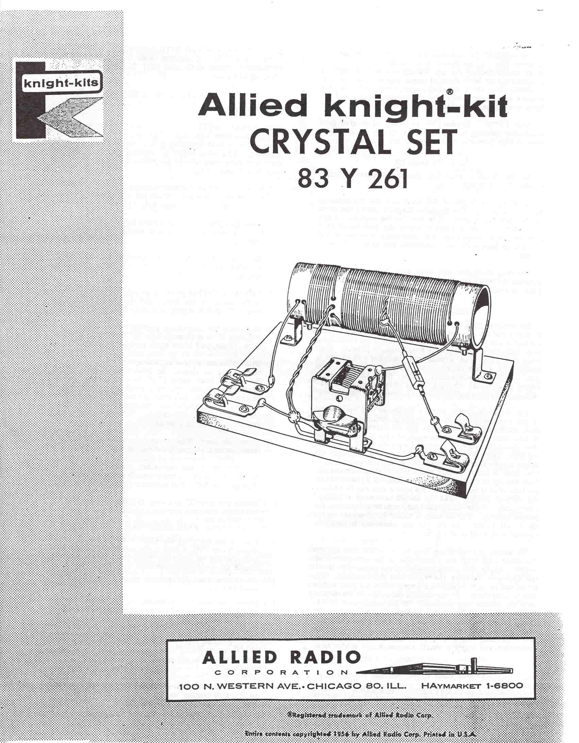

The KNIGHT Crystal Set is the simplest type of radio receiver that can be built. It can be built in a few hours by an inexperienced person. Having no tubes, it requires no batteries or other form of power supply. Yet, in most localities, this little receiver, when connected to a good antenna and ground, will give remarkably clear and reliable headphone operation.
Your KNIGHT Crystal Set is designed to give good selectivity (ability to separate stations) in areas where several high-powered radio stations are located.
CHECKING YOUR KIT
As you unpack your kit, check the parts supplied against the parts list.
Carefully study all of the diagrams and instructions before you begin. The pictorial diagram shows the parts as they actually appear. It is best for the beginner to use this diagram since it clearly shows the position of each part, wire, and connection. The schematic diagram should be used to re-check the connections and to study "How It Works".
The only tools you will need are: Long-nose pliers, diagonal cutters, screwdriver, soldering iron, and a good grade of rosin-core solder .
WIRING AND SOLDERING
Before connecting the enamel-coated wire to a terminal, be sure all of the enamel insulation has been scraped from the end of the wire with a knife. Be careful not to nick the wire with the knife or it may break when it is bent. Then wrap the wire once around the terminal and clamp it tightly with a pair of long-nose pliers. This assures a good mechanical connection. Solder must not be used to supply mechanical strength --its only purpose is to assure a good electrical connection between two conductors.
For most electronic work, a soldering iron rated at 60 to 100 watts with a medium-sized tip should be used. To make soldering easier and to get the maximum transfer of heat from the iron to the work, the tip of the soldering iron should be properly tinned. To tin the tip of a soldering iron, clean it with steel wool, or a fine file, until the bright copper surface of the tip is seen. Allow the iron to heat until it melts solder when it is held against the tip. Coat the tip of the iron with a thin layer of solder. While the iron is still hot, wipe the tip with a soft rag to remove the excess solder. The tip should now have a "shiny" appearance. When using the iron, occasionally check for proper tinning. Try to keep a thin film of solder on the tip at all times. Re-tin the tip whenever it becomes covered with a layer of scale.
To solder a connection, hold the tip of the iron against the connection until the connection is hot enough to melt solder. Apply just enough solder to the connection to fill the crevices between the wires and the terminal. Too much solder will result in a poorly soldered joint rather than a better one. Do not disturb the soldered connection until the solder has hardened. If the connection is disturbed, you will have what is known as a "cold solder joint". Cold solder joints are not good electrical con- nections. If you should accidentally disturb the connection and it hardens with a dull, frosty appearance, re-heat the connection and apply a small amount of new solder to it.

USE ONLY ROSIN-CORE SOLDER
IF YOU ARE IN DOUBT ABOUT THE SOLDER YOU MA Y ALREADY HAVE, WE RECOMMEND THAT YOU OBTAIN A NEW ROLL PLAINLY MARKED: "ROSIN-CORE SOLDER ".

KITS WIRED WITH ACID-CORE SOLDER OR ACID FLUX WILL CORRODE AND WILL NOT WORK PROPERLY. SUCH KITS ARE NOT ELIGIBLE FOR RE-PAIR OR SERVICE.
WINDING THE COIL SEE FIGURE I.
COIL WINDING NOTES: Unwind several feet from the coil
of enameled wire supplied. To avoid kinks in the wire, have someone hold the roll of wire and feed it slowly as required. The wire must be wound tightly on the coil form and each turn should be pushed as close to the last turn as possible-
( ) Pass about 4" of the wire through hole "B" to the in- side of the coIl fonn. Then pull the s;J.me end of the wire to the outside through hole "A".
( ) Wind 20 turns on the coil form for the primary section. If necessary, stop and press the turns tightly together.
( ) After the 20 turns have been wound on the form, leave an additional 5" of wire and cut off the remaining portion.

( ) Feed the end of the primary winding through hole "C" to the inside of the form, and then back out through hole "0". Pull it tightly to anchor it in place.

( ) Now, take the remaining portion of the coil of wire and feed 5" of it through hole "E" to the inside of the form. Then, pull it out again through hole "D".
( ) Wind 30 turns of the secondary on the coil form and make a tap as shown. Be sure to thoroughly scrape the enamel from about 1" of the wire for the tap. Be careful not to nick the wire while scraping. If you desire to be able to adjust the sensitivity and selectivity of your crystal set, additional taps should be placed at 60 and 90 turns. Continue winding the secondary until only about 10" of the wire remains.
( ) After the secondary turns have been wound on the form, leave a 4" length and cut off the remainder.
( ) Pass the end of the secondary winding through hole "F" to the inside of the form. Then pull it out again through hole "G". Pull it tightly to anchor it in place.
( ) Attach the two "Z" brackets to the coil form with the two longer machine screws and nuts.
PARTS MOUNTING
( ) Cut out the template and place it on the board. Make small holes with a nail at the points indicated. This will position the parts correctly on the board and will enable the wood screws to start easily.
( ) Attach the four Fahnestock clips to the board with wood screws.
( ) Mount the two. "L" brackets to the board. Put the solder lug over one of the two short machine
screws. Use this screw-solder lug combination to fasten the tuning capacitor to the left" L" bracket.

( ) Mount the coil to the board.

WIRING

( ) Thoroughly scrape the enamel coating from the end of the wire coming through hole "A" of the coil form. Then, solder it to the antenna clip.

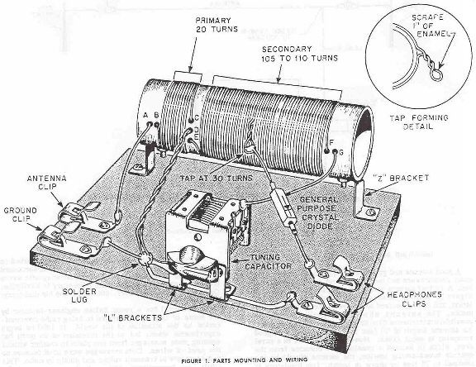

( ) Thoroughly scrape the enamel coating from the ends of the two wires coming through hole "D”. Twist these two wires together. Connect, but do not solder them to the solder lug.
( ) Solder the remaining coil wire coming from hole “G” to the tuning capacitor .
( ) Note that the general purpose crystal diode has an ARROW HEAD marking on one end and a BAR marking on the other end. Some diodes may be marked with a bar or a K, which corresponds to the bar. To prevent heat damage to the diode hold the leads with a pair of long-nose pliers as you solder each lead in place. See Figure 2. Solder the lead from the end that is marked with a BAR (DOT or K) to the head- phone clip nearest the coil. Solder the other lead of the diode to the 30-turn tap.
( ) Solder one end of a 3-1/2” piece of wire to the other headphone clip. Connect, but do not solder, the other end of this wire to the solder lug.
( ) Solder one end of a 1-1/2” piece of wire to the solder lug. Solder the other end to the ground clip.
( ) Place the knob on the shaft of the tuning capacitor . Tighten the setscrew.

( ) Attach the tips of the headphones to the headphone clips.

( ) Attach the antenna and ground leads to their respective clips.

( ) Slowly rotate the tuning capacitor through its complete range. In most areas, you will be able to hear several stations. If you have made several taps on the secondary, move the diode lead to the various taps. Notice the difference in selectivity and sensitivity.

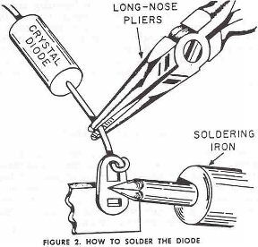

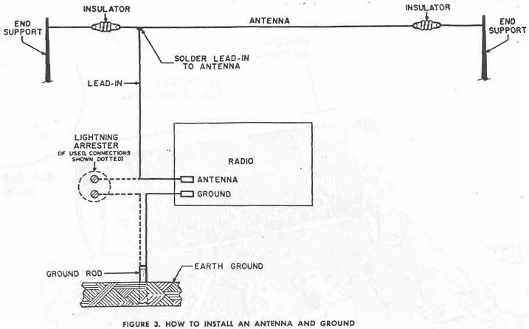

INSTALLING AN ANTENNA AND GROUND
A good antenna and ground are required to obtain maxi- mum performance and most enjoyment from your Crystal Set. A typical antenna and ground installation is shown in Figure 3. Bear in mind that this is only a typical installation, and can be revised to suit your particular requirements. The antenna shou1d be installed as high as possible; a minimum of 20 to 30 feet is usually satisfactory. An antenna length of 50 feet will norma1l provide good reception in most areas. However, If you live in a rural area, which is located a considerable distance from the nearest broadcasting station, the antenna should be increased to 75 feet or more in length. Use insulators at each end of the antenna. It is also advisable to use an insulated lead-in wire. Try to prevent the lead-in from touching trees, buildings, or rain gutters. Such contacts cause signal leakage and result in reduced volume.
A good ground can usually be obtained by attaching a wire to a cold water pipe, a radiator. or a 6 to 8 foot pipe driven into moist ground. To insure a good connection, scrape or sandpaper the pipe.
It is advisable that you use a lightning arrester as shown by the dotted lines in Figure 3. Connect the lead from your antenna to one terminal of the arrester. Connect the other terminal to a rod driven into the ground. If you ground both the lightning arrester and your Crystal Set to the ground rod, use a separate lead for each. Now, bring the antenna connection to your Crystal Set antenna clip.

THE HISTORY OF RADIO .

Radio had its beginning way back in 1873, when Ulysses S. Grant was President of the United States. In this year an Englishman by the name of James C. Maxwell made a prediction that electromagnetic waves, or, as he called them, “ether" waves, could be sent from one p1ace to another, just as light waves were. However, Maxwell died without ever having tested his idea

A young German scientist, Heinrich Hertz, worked on Maxwell's idea from 1885 to 1889. One day he announced that he had succeeded in sending electromagnetic waves from one room to another in his laboratory in Karlsruhe, Germany. Hertz, however, did not pursue his discovery .
It remained for a young Italian engineer-inventor by the name of Guglielmo Marconi to bring radio communication to the attention of the world. In 1890 he began experiments which led to the invention of an outfit for sending code messages from one place to another without the need of wires. Code messages were used because no one knew how to transmit voices and music by radio. This outfit, or transmitter, attracted the attention of Sir William Henry Preece, who encouraged Marconi to "transfer his experiments to England. In 1899 Marconi came to the United States, where he used his method of communication to report the Presidential election of 1900, the year that Teddy Roosevelt was elected to his first term. In 1902 he succeeded in establishing transatlantic communication with Europe. In 1904 Marconi began a daily news service to ocean liners in the Atlantic.
HOW RADIO WORKS
The term radio is used to describe the sending and receiving of signals between two or more places without the use of wires. The signals are sent from the sending or transmitting station in the form of radio waves. A more technical term for radio waves is electromagnetic radiation.
Figure 4 shows a typical broadcasting and receiving system. As the announcer talks, the vibration of his vocal cords disturbs the air molecules, causing them to bump together and create sound waves. The microphone changes these sound waves into very weak audio frequency (AF) electrical waves. These weak AF electrical waves are amplified many times by the speech amplifier.. After amplification, the AF signal 18 mixed with the strong radio frequency (RF) waves In the transmitter. This

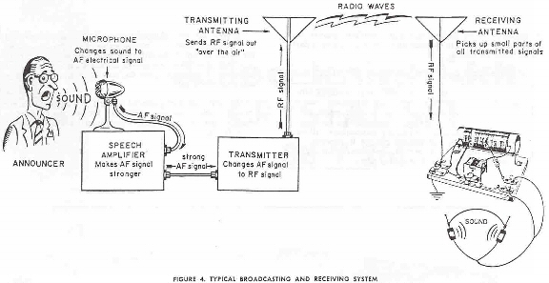

combined signal is then sent up to the antenna where it shoots out in all directions ac a speed of 186,000 miles per second.
At the receiver, the receiving antenna "picks up" a very small part of all the transmitted signals in the air. All of the signals "picked up" by the antenna come down the lead-in to the coil on the radio receiver. The coil with the aid of the tuning capacitor separates the desired signal from all of the rest. The audio waves must be separated from the radio waves before being applied to the headphones. This process is called demodulation, or detection, and is performed by the crystal diode.
The headphones change the electrical waves back into sound waves which strike your eardrums.
Actually, the process just described takes place in a period of time so short that it can scarcely be measured. Practically speaking, the sound of the announcer's voice you hear reaches your headphones ac almost the same instant it has entered the microphone.
So, during a radio broadcast, sound waves are changed into electrical waves; these are changed into radio waves; which are changed back into electrical waves, and then back into sound waves. This all happens in a split second.
ALLIED'S SERVICE FACILITIES
In the event that the kit does not operate properly, please write our Kit Department giving the stock number and the date of purchase of the kit. Also, describe fully what appears to be wrong. Details as to which sections of the circuit do not function properly will help us analyze the problem. We may be able to determine a wiring error or a defective part.

This wired KNIGHT kit may be returned for inspection within one year after purchase for a special service charge of $1.00. Parts within the standard EIA 90-day warranty period will be replaced without charge for the parts. A charge will be made for parts damaged in construction or because of a wiring error, or for parts which are beyond the 90-day warranty period, After the one-year period, service charges are based on the length of time required to repair the unit plus the cost of any new parts that may be needed.
PLEASE NOTE: KITS WIRED WITH ACID CORE SOLDER OR ACID FLUX ARE NOT ELIGIBLE FOR REPAIR OR SERVICE AND WILL HAVE TO BE RETURNED NOT REPAIRED AT YOUR EXPENSE.
Allied's service facilities are primarily for inspection and trouble-shooting, Kits not completely wired, which require extensive work, will be returned collect with a letter of explanation,
If you return this kit, pack it well, To prevent damage in shipment, use a large enough carton so that cushioning material can be placed around the unit. Cushion it well and tightly. Mark the carton, -FRAGILE--DELI- CATE ELECTRONIC EQUIPMENT". Send the kit prepaid and insured. We will return the repaired kit to you C.O.D. as soon as repairs are completed, If you wish to save COD fees, your advance remittance may be enclosed to cover the standard repair charges plus transportation costs. Any excess money will be refunded.
ALLIED'S GUARANTEE ON KNIGHT KITS
The designs and components selected for KNIGHT kits represent over a quarter of a century of experience in kit development, KNIGHT kits are easy to assemble even for a beginner. The instructions are complete, panels are drilled, the chassis is punched and formed, and every part is included as listed.
Allied extends these firm guarantees on KNIGHT kits:

We guarantee that the circuits in all KNIGHT kits have been carefully engineered and tested.
We guarantee that only high quality components are supplied. All parts are covered by the standard EIA 90-day warranty. Any faulty components will be replaced prepaid and without charge if reported to
us within the warranty period. We reserve the right to request the return of defective parts.

If your kit was shipped by parcel post and is received in a damaged condition, please write us at once describing the state in which the shipment was received. If your kit was part of a Railway Express shipment that was damaged in transit, please notify the Railway Express agent at once and then write us.
The efficiently engineered KNIGHT kits are moderately priced. When you buy a KNIGHT kit you get the best in design, quality, and value. Recommend KNIGHT kits to your friends.

