The Pack 57 Buffalo Den Crystal Radio part 1

As a Cub Scout leader I was always looking for something a bit different for the boys to try beyond the standard fare suggested in the hand books. A popular project from decades past was a crystal radio. Working only off the energy provided by the radio waves, it still seems magical to me but would it command the same attention of the boys with today’s high tech toys? I would say it worked quite well. So at the suggestion of some, I’m putting this out via the wonders of the high tech internet of today so people can enjoy the high tech of years gone by.

Once assembled, the radio does a good job of picking up strong AM broadcast stations here in the Chicago suburbs. It is not very selective meaning you will hear more than one station if there are multiple strong stations in your area as there are in the Chicago area. For the electrically inclined, this radio does not use a tuning capacitor as that would raise the cost above what would be acceptable for a scout project. The capacitance needed comes from the turn to turn capacitance of the coil and by using an antenna that is much shorter than the wave length of the radio signal.

There are many ways to approach this project. In a more traditional approach, building each part of the radio could be done over a series of den meetings. I had no convenient way to store all the parts so this project is designed to be assembled by the boys in about one hour with parents help. To do this, some of the parts need to be set up ahead of time. The instructions in part 1 are made with my non-electrically inclined co-leaders in mind on how to set this up for a den meeting. Parts used are meant to be readily available. Part 2 is meant to be handed out at the meeting as instructions for assembly by a Cub Scout and adult assistant. I had these built at our regular meeting room in a grade school which I think is lead lined as it still gets no cell phone service. We could not tell if the radios were working until the kids got them home. When they did not work I told them to bring them to my house where most problems were caused by bad connections or the coil needed a little more sanding for the wiper to make contact. I also used a continuity tester to check the wiring each scout made to ensure the radios would work when they got them home.

1. Get the parts

PARTS for one radio, scale up as needed. I had a beveled edge cut on the board and stained it. I used brass screws and washers. I did this to make it look just a bit classier than it normally would have looked. I assembled all the parts below into plastic bags to make a small kit for each scout. I bought extra diodes and ear phones as they are obtained from surplus sellers and may have varying quality.

1 inch PVC pipe cut to a length of 4 inches
- 5 X 7 X ¾ inch pine board
- 27 feet of 28 gauge ENAMELED copper wire, make sure it is enamel coated and not bare copper. I got my wire from a local motor repair shop. The owner was happy to help scouts and gave me what was left on a spool which was more than enough for radios for two dens.
- 47,000 ohm carbon resistor. This can be between 30,000 and 100,000 ohms. Resistors come in various sizes which do not matter in this project, the photo shows a ½ watt size resistor. If you know a Ham Radio Operator they might have boxes of these that you can get from them a lot easier than from Radio Shack. If you find or have a bunch of salvaged resistors, you can determine the total resistance by reading the color code rings. The code can be found at
http://en.wikipedia.org/wiki/Electronic_color_code
- 7 brass screws
- 6 brass washers
- One large metal paper clip
- 6 feet of insulated hook up wire
- Alligator clip
- Ceramic ear phone, make sure this is a ceramic ear phone and NOT a magnetic earphone or head phone or ear buds. Only the ceramic ear phone has the high efficiency that can covert the weak radio signal energy into something that can be heard.
- 1N34 or 1N34A signal diode. Make sure this is a signal diode and not a zener or power supply diode.
As of this writing, 2008, you can get diodes and ceramic ear phones at….
http://www.angelfire.com/electronic2/index1/
part #s
GREEN1N34A-1 $0.25
CEREAR-1 $1.97
You can also find information on
http://www.crystalradio.net/
- Antenna wire. About 30-100 feet of insulated wire. Length is not crucial as long as it is over 30 feet. If you live far away from big AM stations, go longer.
- You will also need a soldering iron and rosin core solder
- Clear lacquer spray
- 100 grit sand paper

2. Make the coil
I did this with the help of another adult but a scout could help instead.
- Cut the PVC into 4 inch sections.
- Drill one 1/16 inch pilot hole at each end of the coil for mounting screws. Use a template to do this so you can drill pilot holes on the board in the right spot later.
- Drill a ¼ inch hole on the opposite side of the pilot holes. This hole has to be big enough for a screw driver blade to go through later when you mount the coil to the board.
- Drill one more pair of 1/16 inch holes at a point 90 degrees from the first holes. This will be where you can pull the coil wire through the PVC to secure it and pull the wire out of the ends of the PVC later.
- I slid the PVC over the end of a variable speed drill. I strung about 12 inches of wire off a spool through one of the holes mentioned in the step above. While wearing gloves, I guided the wire into a coil of about a 2 inch length while my partner slowly ran the drill. The overall size is not very crucial. Just try to keep the windings from crossing over each other. You want a smooth coil that the slider will more on smoothly. When you have the coil wound. Pull the last end through the other hole tightly to keep it from un-winding.
- Spray the coil with a clear lacquer to keep it in place and set it aside to dry.

.
3. Prepare the boards
- Cut your boards to 5 X 7 inch sections.
- Using the template from drilling the pilot holes for the coils and the general pattern shown on the drawing and photo, drill two pilot holes for mounting the coil and 5 pilot holes for the screws used to connect the wires. Make sure the holes are close enough the connect the leads of the resistor and diodes later.

4. Make the slider
- Un-bend the paper clip
- Bend the paper clip into a ‘S’ shape
- Bend one end into a circle that will fit onto one of the washers
- Bend the other end back as seen on the photo
- Using a partner, hold the clip on the washer.
- Heat the washer and the clip with the soldering iron and solder the washer to the clip.
- While you have a hot soldering iron, solder 2 inch sections of hook up wire to the wire end of the ear phone. This will make hook up to the screws easier.

5. Ground clip and hook up wires
- Make the ground clip by attaching it to a segment of hook up wire about 4 feet long with the insulation stripped off the ends. Coil it up for storage.
- Prepare two hook up wire segments by cutting two, 2 inch segments and stripping the insulation off the ends.

6. Antenna
I use an antenna made of insulated hook up wire about 40 feet long. I use insulated wire to avoid any problems or poor performance caused by accidental contact with a metal object. Coil it up for storage.

Mount the coil to the board and using the sand paper, sand of the enamel on the top of the coil where the slider will make contact. You may need to sand a bit more after each radio is assembled. Place it and the other parts in a bag along with the instructions below. The only assembly tool needed would be a screw driver appropriate for the type of screws used.

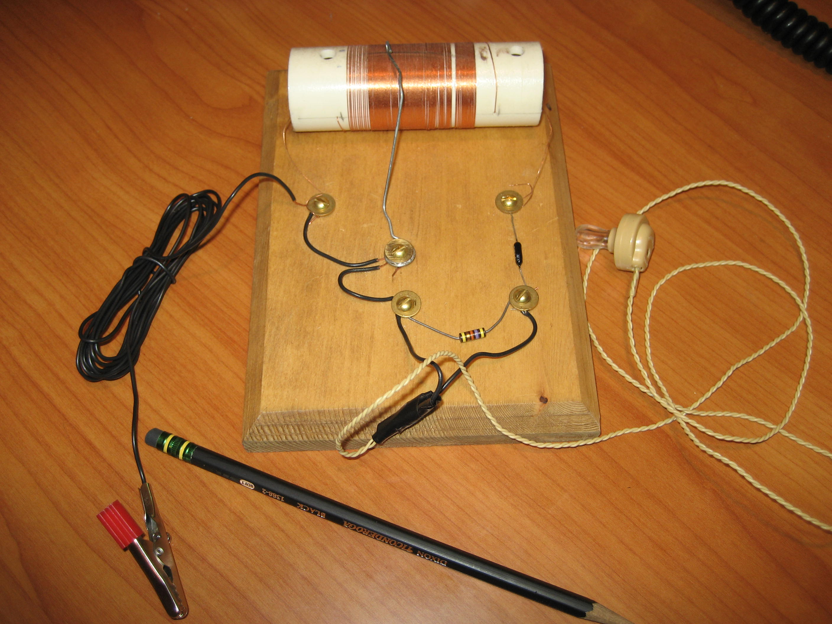

N9JLF

The Pack 57 Buffalo Den Crystal Radio part 2
With only a handful of parts and simple antenna, in 5 steps we’ll build a radio that will pick up several radio stations all without batteries.

The parts consist of

- Tuning coil
- Diode
- Resistor
- Hook up wire
- Wiper
- Earphone
- Antenna wire
- Ground wire and alligator clip
- Washers and screws
- Mounting board

The tuning coil comes already mounted to the board. Holes for screws are pre-drilled. The only tool need is a screw driver.

NOTE
When attaching wires,
Attach them UNDER the washers
and wrap CLOCKWISE

- Attach two pieces of hook up wire, washer, wiper, and screw as shown in the drawing. Tighten the screw to hold the parts in place but ensure the wiper can move back and forth on the coil.

- Place a screw and washer on the right side of the coil and attach the wire on the right side of the coil to the screw. Also attach the antenna wire and one end of the diode.

- Place a screw and washer on the left side of the coil and attach the wire on the left side of the coil along with the hook up wire going to the wiper and the ground wire.

- Place a screw and washer on the middle front part of the board and attach the other hook up wire going to the wiper, one end of the resistor, and one of the wires for the earphone.

- Place a screw and washer on the right front part of the board and attach the other end of the resistor, the other wire for the earphone, and the other end of the diode.

That’s it. While you’ll probably not be able to pick up much of anything indoors at school, at home you should be able to pick up most of the bigger AM radio stations. Stations from far away can be heard after dark.

Here are suggestions for how to set up your crystal radio.

WARNING
DO NOT
Under ANY circumstances
Plug ANY part of
This radio into a
Wall outlet

A good antenna and a good ground are essential in getting the best performance from this simple radio.
The antenna wire is insulated so it can be run through a closed window as long as you do not pinch it very hard.

Good antennas
Wire run out 2nd floor window to nearby tree branch
Wire run out second floor window to a tree branch or fence post where no one will walk into it.

OK but not the best antennas
Wire run along a first or second floor bedroom or hallway
Wire run along a basement ceiling

Bad antennas
Wire run along the basement floor
Wire run inside any metal building

Make sure ground connection is to clean bare metal.

Good grounds
Steel ground rod for your house wiring, usually found below your electric meter, have an adult connect this.
Cold water pipe
Sink faucet as long as you have metal piping going to sink.
Outside of electric conduit, have an adult connect this.
Steel I beam house support

OK but not the best ground
Heating/AC register
Metal Window frame
A longer ground wire (20ft) just laid on the floor.
Ground wire wrapped around metal drain pipe or water pipe.

Bad Grounds
No ground
Plastic pipe
Wood frames

How to work the radio
With the radio connected to an antenna and good ground, and wiper in the middle of the coil, you should hear one or more stations at the same time. Try moving the wiper to different positions on the coil. Different stations should change in loudness as you move the wiper.

If you hear nothing, then make sure you have good connections. Remember that this radio works best with a good ground and antenna.

How it works
Radio stations convert sounds into radio waves and send out the waves everywhere. Radio waves travel across the crystal radio antenna all the time. Radio waves make electricity flow between the antenna wire and the ground wire. This electricity is connected to the crystal radio. The crystal radio uses a tuner to tune the electricity to receive just one station. Then it uses a detector to convert this radio wave electricity back to sound electricity. It uses a sensitive earphone to convert the sound electricity to sound you can hear.
